HW2 – Fractional Crystallization using MELTS
Part 1 – What affects viscosity
We are using the Giordano et al. Viscosity model in the python package Thermobar to calculate viscosity.
1a. What is the viscosity of the basaltic composition at 1150C with 0 wt% H₂O?

1b. Now increase the water content to 3 wt%. How much does viscosity change? What effect does adding water have on the viscosity?

1c. Now of course, adding water means in reality, the temperature has probably gone down (if you have any crystals around). The liquidus temperature decreases by ~10℃ per 1 wt% water added (Putirka, 2008). So now run the calculation again, but adjusting the temperature to account for this. Does decreasing temp cancel out adding water?

1d. Now perform the calculation for the rhyolite also at 1150C, with no water initially. Temp and water content is the same – what is making the rhyolite more viscous?

1e. A more reasonable Rhyolite Temperature is 850C. What is the viscosity with no water at 850C?

1f. What temperature and/or water contents do you need to get the viscosity back to the 100s of PaS like the basalt? Is this at all plausible?

Part 2 – Calculating melt liquidus temperatures
2a – What is the liquidus temperature and liquidus phase for the basaltic bulk composition with no H₂O at 1000 bars?

2b – Now calculate the liquidus at 5000 bars. What is the liquidus temperature and liquidus phase?

2c – Why is the liquidus at a higher temperature at higher pressure?

2d – How does the liquidus phase change as you change the water content and pressure? Try 4 different pressure and water content combinations and see what phases you get. Make sure to state what pressure and water contents you used.

2e – Now calculate the liquidus phase and assemblage for the rhyolite at 1000 bars, 0 wt% H₂O

2f – Using the equilibrate_multi function, what phases are present at 60 °C below the liquidus temperatures calculated for 1200 °C and 1000 bar at 0.0001 and 1 wt% H₂O?

2g – Calculate the viscosity for this system now vs the viscosity at the liquidus

Part 3 – Lets investigate how phase stability and liquid lines of descent change as a function of oxygen fugacity, achieved here by varying Fe^{3+/}Fe_{T} in the melt
3a- Look at the major element plots – what are the biggest changes between different models? What major elements are most impacted?

3b – Looking at the phase abundance plots, what is the biggest difference between FMQ-1 and FMQ+2? What is the chemistry of these phases – and why do they cause SiO₂ to go up?

Part 4 – Lets investigate how phase stability and liquid lines of descent change as a function of water content.
We are going to be using the isobaric_crystallization function, Lets run at 0.5, 2, 4 wt % water at 2 kbar.
4a) What major elements show the biggest differences between models run at different water contents?

4b) What is the liquidus phase and dominant phases present at each water content?

4c) Change the x axis to be temperature – what happens to the abundance of solid phases at each temperature?

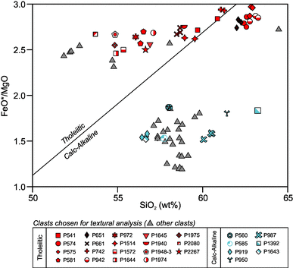
4d) The Calc alkaline vs. tholeiitic magma series is typically classified after Miyashiro et al. (1974) in SiO₂ vs. FeO/MgO space (see plot directly below). Calc alkaline magmas show early Fe removal, Tholeiitic magmas show Fe enrichment during early differentiation.

First, plot the Isobaric_Xtal_H2O water series data on the Miyashiro et al. (1974) diagram. Do any of them cross into the calc-alkaline field? How do the different water contents behave on this plot? How do their Fe enrichments compare?

4e) Now make the same plot for the fo2 series (Isobaric_Xtal_fo2) – Screenshot your plot below and comment on the behavior of each model.

4f) From these two comparisons – what conditions can you conclude favor the formation of calc alkaline vs. tholeiitic lavas? Using the lecture slides so far, what tectonic setting should this occur in?

